REPORT ON WORLD AIDS DAY 2022

INTRODUCTION
As a part of the World AIDS day Celebration, We community Health Nursing Department conducted an awareness program on 5th Dec 2022. The program was conducted in the Dungri Faliya, Dungra UPHC.
The group health education was focused on the definition, mode of transmission, clinical manifestation, management and prevention of HIV/AIDS.
OBJECTIVES
The main objective of World AIDS Day is to create awareness on what is AIDS.
AIDS (Acquired Immune Deficiency Syndrome) is a medical condition caused by HIV that sabotages the immune system of a person making it vulnerable to infections including opportunistic infections.
1. To create a awareness regarding HIV/AIDS
2. To provide information regarding HIV/AIDS, causes, Risk factors, sign and symptoms and its prevention to community people.
3. To remove stigma against HIV/AIDS
4. To enhance the knowledge of community people by providing health education
5. To give awareness of govt. to prevent HIV/AIDS

THEME
World AIDS day 2022 theme:- “Equalize”
The “Equalize” slogan is a call to action. It is a prompt for all of us to work for the proven practical actions needed to address inequalities and help end AIDS.
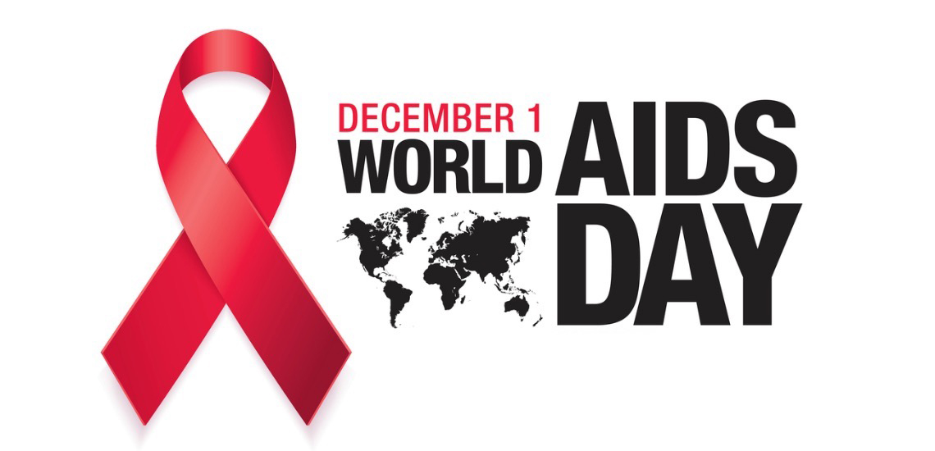

REPORT OF HEALTH EDUCATION ON HIV/AIDS
Sandra Shroff ROFEL College of Nursing, Vapi organized event on world AIDS Day on 5th Dec 2022.
The main aim of celebration of World AIDS Day : To raise awareness about HIV/AIDS and to support the people living with HIV/AIDS.
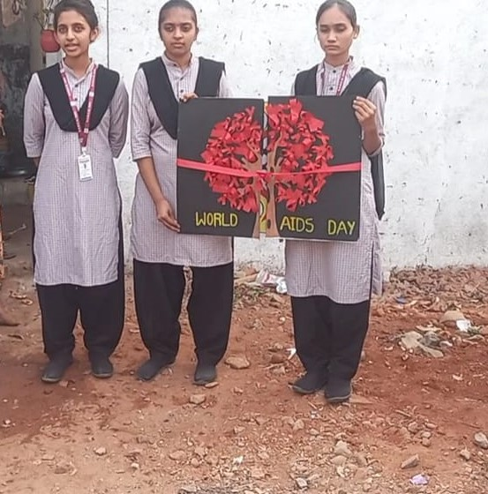
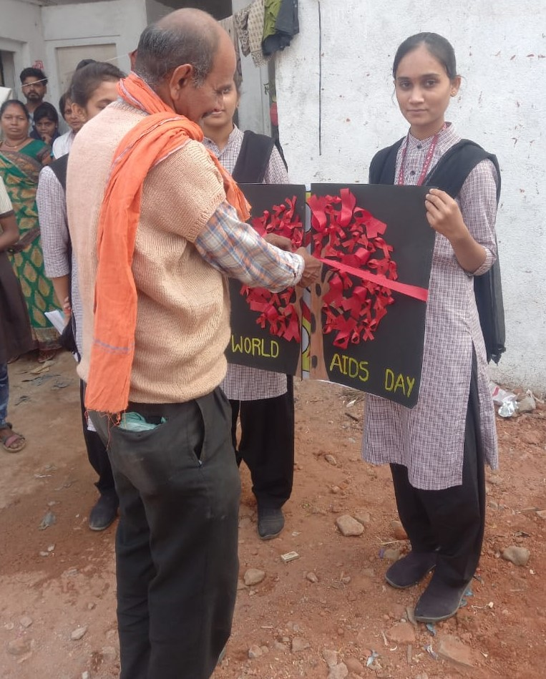

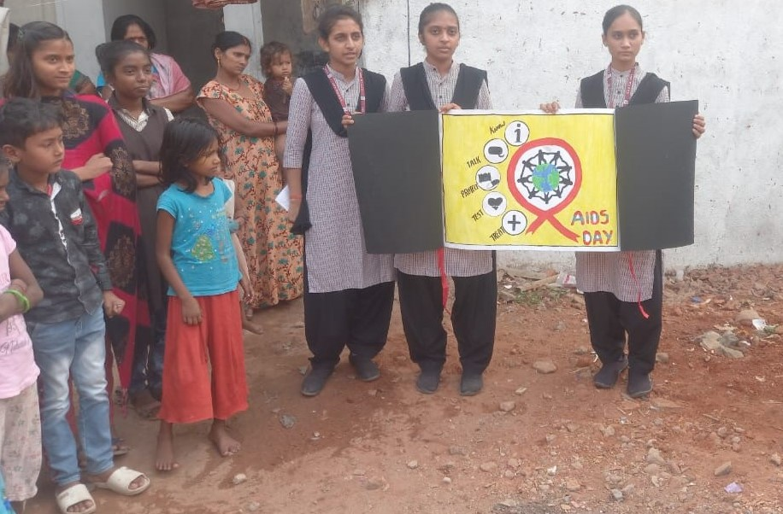
Health awareness program was organized by First Year G.N.M Students. Ms. Princy, Ms. Priya, Ms. Hetal , Mr. Manish, Ms. Priya K , Ms. Khushi G and Ms. Vruti gave health talk on cause, risk factors, clinical manifestations, management and prevention of the HIV/AIDS.
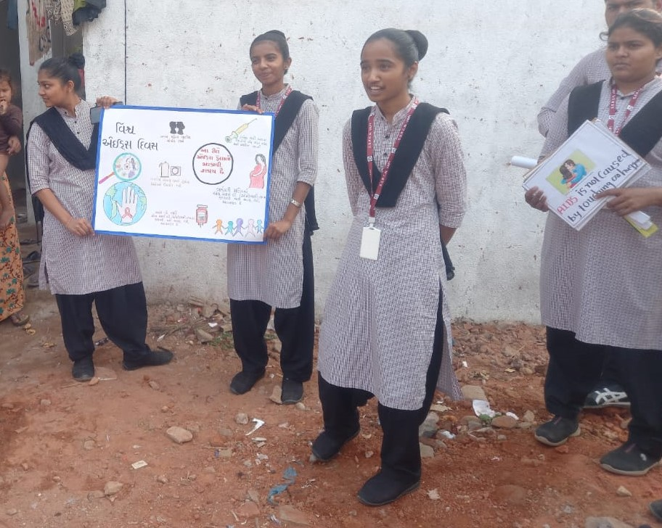

CONCLUSION
As a part of curriculum, the students of SSRCN and faculties participated in AIDS awareness event with the guidance of Maj. Gen. TK Bhutia (Retd), Academic chairperson and Principal, SSRCN.

